MAHEE SHAH

|  |  |  |
| --- | --- | --- |
| **Assignment** | **:** |  |
| **Understanding of Hardware and Its Components** | | |

**Section 1: Multiple Choice**

1. Which of the following is NOT a component of the CPU?
   1. ALU
   2. RAM
   3. CU
   4. 1 and 3 both

**ANS- RAM is not component of CPU bcoz it’s a storage device that stores temporary data.**

1. What is the function of RAM in a computer?

**ANS- RAM stands for Random Access Memory . Its function is store data so that it can be retrieved quickly whenever needed by the computer.**

1. Which of the following is a primary storage device?
   1. HDD
   2. SSD
   3. SD card
   4. 1 and 2 both

**ANS- HDD because data is not stored when computer is powered off.**

1. What is the purpose of a GPU?

**ANS- GPU stands for Graphic Processing Unit. It makes data usable quickly for gaming purposes, video editing and completing high level tasks that requires speed.**

**Section 2: True or False**

1. True or False: The motherboard is the main circuit board of a computer where other components are attached.

**True. Bcoz it is the main board where all external parts are connected.**

1. True or False: A UPS (Uninterruptible Power Supply) is a hardware device that provides emergency power to a load when the input power source fails.

**True. Bcoz it provides backup power in case of such emergency power failures.**

1. True or False: An expansion card is a circuit board that enhances the functionality of a component.

**True. Bcoz expansion card allows to add other components to ur system.**

**Section 3: Short Answer**

1. Explain the difference between HDD and SSD.

|  |  |
| --- | --- |
| **HDD** | **SSD** |
| It is cheap and slower. | It is more expensive and faster. |
| It consists of moving parts. | It doesn’t have moving parts. |
| It stands for Hard Disk Drive. | It stands for Solid State Drive. |
| It has more power consumption due to more heat loss. | It has less power consumption. |
| It is less portable. | It is more portable. |
| It doesn’t have NV RAM. | It consists of NV (non-volatile) RAM so that data is saved when the computer is turned off. |

1. Describe the function of BIOS in a computer system.

**ANS- BIOS stand for basic input output device. Its starts the system after comp is powered on and helps to start hardware devices that are attached.**

**-**

1. List and briefly explain three input devices commonly used with computers.

**ANS- Keyboard : it used to enter data to computer system**

**Mouse : it is a pointer used to click several icons, files and folders on the screen .**

**Barcode reader : it used to scan the barcode to capture info. Which can be stored in system .**

**Section 4: Practical Application**

1. Identify and label the following components on a diagram of a motherboard:

* PCI slots**- I**
* CPU - **M**
* RAM slots - **A**
* SATA connectors – **G**

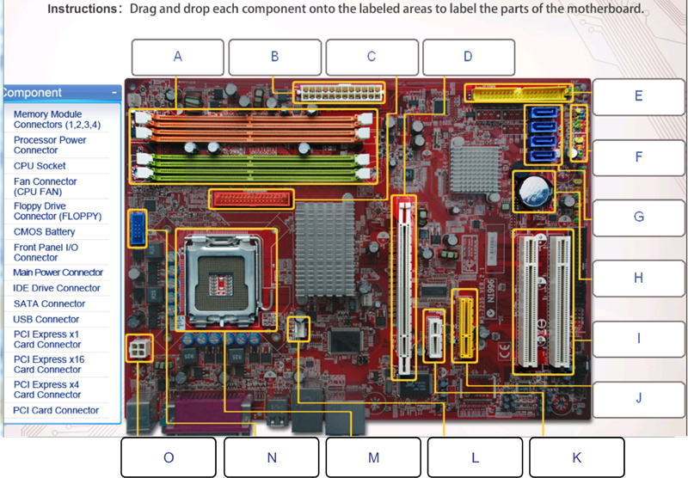

1. Demonstrate how to install a RAM module into a computer.

**ANS- arrange the RAM in the line of slot and then slightly press RAM into the slot.**

**Section 5: Essay**

1. Discuss the importance of proper cooling mechanisms in a computer system. Include examples of cooling methods and their effectiveness.

**ANS- Due to overheating in comp. systems cooling mechanisms are important to protect from any hardware failures and also for long use of computer.**

* **Air cooling- in this method fans are used counter the heat produced and provide cooling.**

1. Explain the concept of bus width and its significance in computer architecture.

**ANS- It refers to no. of bits that can be transferred across a bus. it affects system data transfer rate . A wider bus gives more data at once.**

**A 32 bit bus transfers 32 bit at a time and a 64 bit bus transfers 64 bit at time affecting speed and efficiency.**